Fantasy Pro Tour: Los Angeles Bargain Picks
Alex Shvartsman
Fantasy Pro Tour is a great way for the spectators to get involved with the Pro Tour on a slightly more personal level - by picking their favorites, then following their progress over the weekend. The new rules of the game make it a little more challenging - you can no longer simply pick eight of the best-known names on the Tour, you must now make sure that the combine "worth" of your team is 100 points or less.
While this makes for a more interesting and challenging game, it is also more difficult for those players who are not extremely knowledgeable about Pro Tour players. Many of you will have no problem selecting several favorites - such as Jon Finkel, Brian Kibler or Kai Budde - but will be at a disadvantage when trying to fill out the rest of the team, working with the less-known players at 0-5 point level.
In this article, I will introduce you to some of these players I am familiar with. There certainly may be other great choices on the list, but I can only speak of those players familiar to me. Listed below are some old veterans returning to the game, and the hottest up-and-comers in the format.

0 POINTS
Truc Bui
A Pro Tour veteran, Truc Bui was dominating the scene long before most people heard of Jon Finkel or Kai Budde. Along with Brian Hacker and his other teammates in California, Bui helped develop the strategies and theories behind the draft format, as well as popularize the "money draft" format, which still dominates the evenings at Pro Tour events. Bui has two Pro Tour top 8 finishes to his name. Chances are pretty good he will show up for this tournament, since it is in his home state - and if he took any time at all to practice, it would be reasonable to expect a good finish.
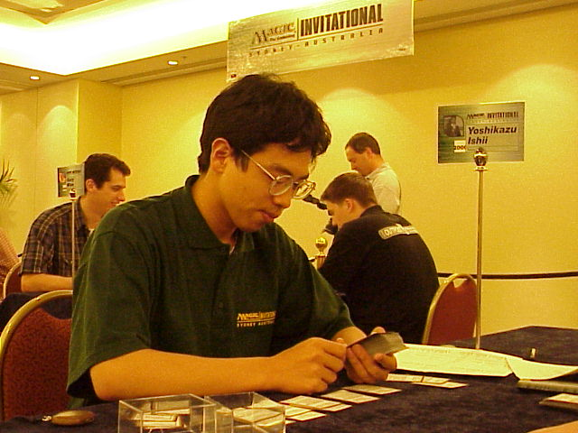
Yoshikazu Ishii
Best known to the international Magic community for attending the Magic Invitational in Australia, Ishii is also a winner of the huge Grand Prix: Kyoto, and a Top 8 finisher at GP Tokyo. He proved his ability to play against the best, finishing 5th at the Invitational, and being credited with designing the most interesting Bring Your Own Block deck there. Ishii is sure to have put some effort into preparing for this tournament.
Pierre Malherbaud
This competitor has had a number of strong finishes in 1998 with a top 16 and two top 64 finishes. He seems to have dropped from the tournament scene after 1999, but he is back at a fresh start now, and may be well worth the gamble of picking for your team on the strength of his tournament record.
Cary Newburger
A true veteran, Newburger used to be a Pro Tour regular back in 1996. He played in a couple of Pro Tours since, but have not really caught a break yet. Newburger is a regular at Neutral Ground: New York. He plays almost no constructed Magic, but is an expert at almost every Limited format you can imagine. I am willing to bet few people attending PTLA will have done more Invasion drafts than Newburger.
Ron Schubert
One of the youngest pro players, Schubert has been competing in Magic tournaments since the age of 12. His top finish was 14th place at PT NY in 1999. Schubert has not competed in that many Pro Tours yet, but he grew up around the Magic scene, knows what's what and is likely to do well again soon.
Dan Silberman
One of the less-known CMU players, he is perhaps best recognized for a top 8 finish at GP Toronto. CMU has produced many of the game's top players. Last year was Aaron Forsythe's turn to break through. Perhaps this year is Silberman's.

1 POINT
Menno Dolstra
This Dutch player recently braved some very tough competition to make top 8 at Grand Prix: Amsterdam. This is Dolstra's second Pro Tour, but his performance in Amsterdam indicates strong understanding of Invasion draft format, making him a very attractive pick at only 1 point (which comes from last year's Team Grand Prix: Frankfurt - also a Limited event, where Dolstra's team finished 8th).

2 POINTS
Itaru Ishida
One of the most experienced Japanese competitors on the Pro Tour, he has been around since the days of the Junior Pro Tour, where Ishida did reasonably well. He is also one of a handful of Japanese players to reach a Pro Tour top 16. Ishida has three Grand Prix top 8 finishes to his name, an impressive resume for only two points.
Hogan Long
Despite playing the game for many years, this is Long's first individual Pro Tour. Webmaster of NeutralGround.net, Hogan Long is very similar to his friend Cary Newburger in that he spends a lot of his free time playing Limited formats at Neutral Ground, and will come to LA with a lot of experience to add to his talent. Long qualified by making top 16 at Grand Prix: Dallas.
Jeff Magid
A solid player from Boston area, he is likely to benefit from opportunity to practice with Your Move Game players, as well as his teammates Chris Senhouse and Joel Frank, of team Diesel.

3 POINTS
Danny Mandel
Mandel too has never before competed on an individual Pro Tour. He has however been practicing with team Your Move Games and the rest of the Boston crew, his commitment resulting in a 9th place finish at Grand Prix: Dallas. Mandel is much hyped by his friends, who feel he is likely to become a Pro Tour regular.
Dustin Stern
Stern is relatively new to the game of Magic, and has never played on the Pro Tour before. Yet he enters PTLA with two Grand Prix top 8 finishes to his credit, that qualify him for LA and Barcelona, as well as a PTQ win that assures him a spot in Tokyo. He is certainly one of the most interesting newcomers to watch in Los Angeles.
Tony Tsai
Another old timer, this member of Team Deaduy has a pair of Grand Prix top 8 finishes and a number of Pro Tour appearances, yet he never broke the top 16 mark. A strong competitor, he is one of those players who PT regulars feel is "due" a strong finish.
Emmanuel Vernay
This French competitor's claim to fame is winning the very first Grand Prix ever held, Amsterdam in 1997. His only individual Pro Tour appearance to date is PT Paris, where he placed 45th. Vernay attended Team PTNY earlier this year, so he is likely to show up in LA. If you are looking for a solid European old-school player to support, he may be a good choice.

7 POINTS
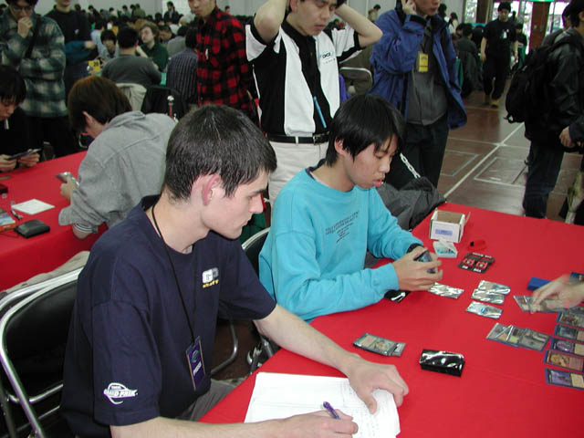Katsuhiro Mori
Seven points is hardly a bargain - but it may be for this young Japanese player. Mori was invited to the Magic Invitational in Sydney as the highest ranked player in Asia, but was unable to attend due to school. He then went on to prove that he deserved the invitation - by making top 8 at three consecutive Grand Prix! No other player has ever managed that to date. Mori has never attended a Pro Tour before, but he will be playing in Los Angeles and Tokyo.
Ben Farkas and Brian Schneider would be on my list, but I was told that Farkas will not be attending (I do not know this for a fact) and Brian Schneider certainly won't play - he has been hired by Wizards of the Coast and can no longer compete on the Pro Tour.

My Fantasy Team
55 Alex Shvartsman
16 Casey McCarrel
12 Svend Geetsen
07 Katsuhiro Mori
03 Dustin Stern
03 Tony Tsai
01 Menno Dolstra
00 Truc Bui
Most of my choices are explained above. I picked myself because - well - if you plan to attend a Pro Tour, you must believe that you are going to win. Otherwise, why are you even going? It has been somewhat of an unwritten rule for Fantasy PT to always pick yourself, and I would do so even if I was worth 100 points. I don't really recommend myself as a good choice to others, as hardly any player is worth 50+ points.
I consider Casey McCarrel an excellent choice at 16 points. A Pro Tour champion and a strong contender, his low number of Pro Tour points is caused by the six month sabbatical he took from the game last season. McCarrel has quickly climbed back within striking distance of the Gravy Train, and will likely be worth considerably more points in the future fantasy PTs.
Same is true for Svend Geertsen. Having missed several Pro Tours in favor of traveling in South America, Geertsen is back. Among the most popular players both for his skill and personality, Geertsen is likely to regain PT points quickly, so I rushed to pick him at 12.
Good luck playing the fantasy PT. Remember, all teams are due by early Friday morning, so submit yours soon.
Visit the Fantasy PT page here.

